An opportunity for European StartUps and SMEs
to co-develop an innovative solution with European Digital Challenge Owners

DigiFed Digital Challenge  The Digital Challenge is an Open Innovation challenge, which falls under the umbrella of the European funded project DigiFed. It is an opportunity for technology providers to address the needs of large corporations and apply their technology in novel environments, with support from Europe’s leading innovation centres and clusters.  The Digital Challenge identifies and highlights attractive market needs to be addressed through cyber-physical systems (CPS) and embedded systems and for which no solutions currently exist.  The second edition is organized in collaboration with ACCIONA as early adopters of the accelerated innovations which provide additional support to the programme in the form of co-funding, access to innovation support and pilot sites. | If you are a Start-Up or SME:  - Developing innovative smart solution worthy of market leaders  - Bridging the physical and virtual worlds with advanced technologies and industrialized solution  - Wishing to open to the European market and directly collaborate with a large corporation  Then this challenge is for you!

This Digital Challenge offers you:  - Opportunity to respond to a real-world industry challenge adding a relevant use case to your unique value proposition  - Support aimed at bringing your innovation to target market through:  - Added value to your product, access to high-level technical expertise and to pilot sites to deploy your solution  - Access to Innovation Management programme focusing on European sustainable development  - Financing support  - Up to €100.000 for 9-12 month project (co-funding between DigiFed and the Digital Challenge Owner)  - Covering 70% of your project’s declared budget | Applicant’s profile:  The Digital Challenge targets StatUps and SMEs with existing customer experience and minimum viable products or services, which can offer innovative and breakthrough solutions that matching the Digital Challenge Owners’ needs.  Legal entities established in the member states of the European Union (including their overseas departments), the EU associated countries and the United Kingdom are eligible to apply.

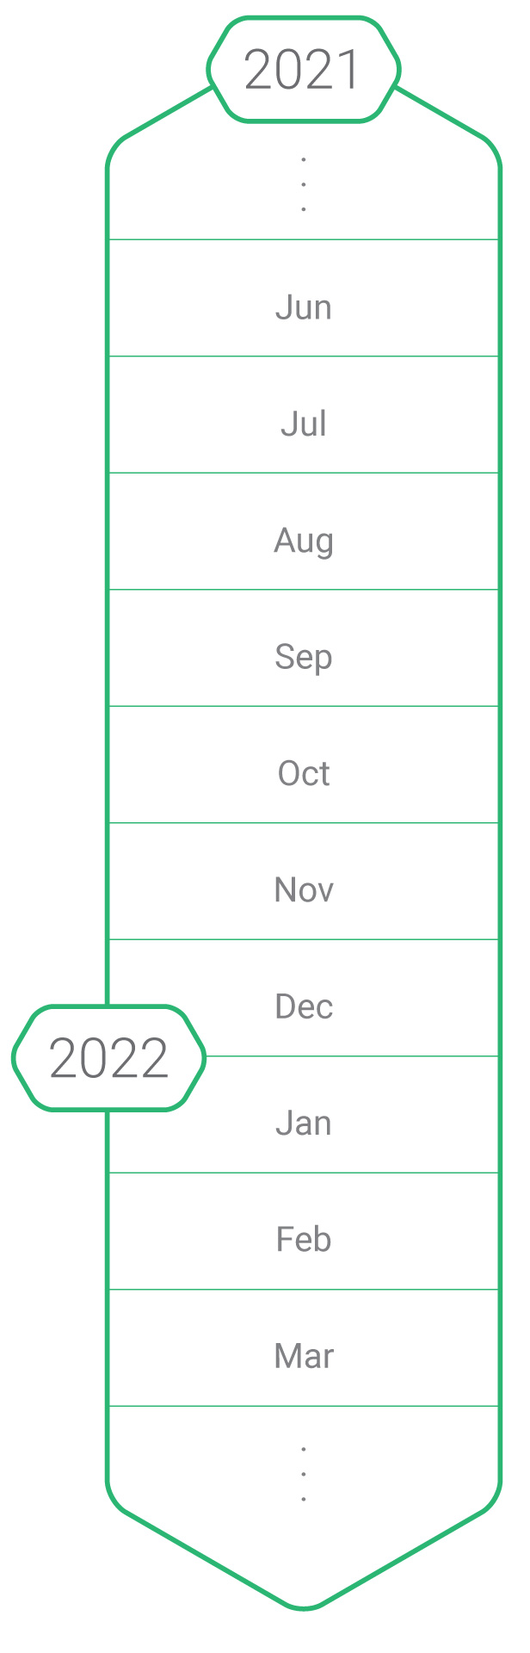
Application timeline:
Launch of the Digital Challenge
Open Call – June, 9th
Digital Challenge Webinar – June, 17th
Q&A session – June, 23rd

Pre-selection – July, 16th
Digital Challenge Discovery webinar with the DCOs – August
A Signature of a NDA is required

Proposal submission – September, 14th
Open call Deadline

Evaluation & selection of applications: September / October
Applications are reviewed with DCO and DigiFed Partners
Selection confirmed by the European Commission

Contracts signed off: November
Signature of Digital Challenge Standard Contract and NDA documents (if required)

Digital Challenge – Kick-Off: January 2022
KO meeting with DCO, selected 3rd party and DigiFed Partners involved

Digital Challenge – Development: 9-12 months
- Regular progress review meetings
- Milestones sign offs
- Training (if required)
- Testing/ Deployment
- Demo
- Project Conclusion

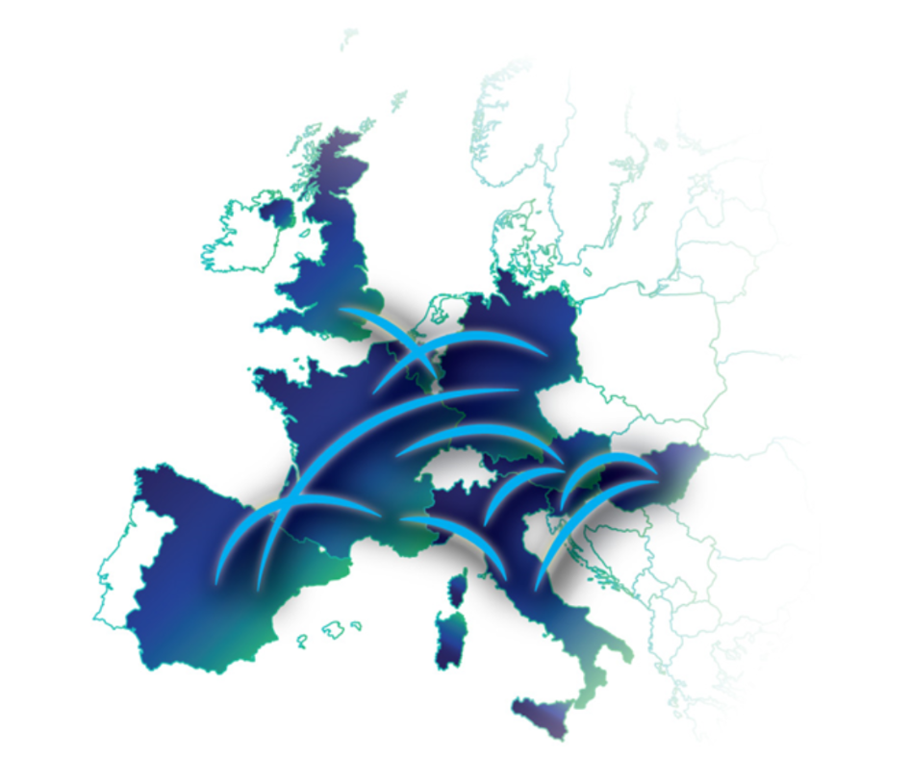
More information about Digifed:
DigiFed is an EU funded innovation action on the H2020 program. Its main goal is to drive innovation across European SMEs & Midcaps via large-scale adoption of Cyber Physical Systems (CPS) & Embedded Systems.
3 Open Calls and 3 Main Innovation pathways are planned to help SMEs & Midcaps digitally transform their operations, products, and service offerings.
Facts and figures :
- 12 Partners from 9 European Countries
- Duration:​ 3 years, 01 January 2020 to 31 December 2022​​
- Cascade Funding: €3.9 million in direct support for SMEs & Midcaps
More details : https://digifed.org/

Application form:
Please return your application by submitting your form here https://digifed.org/upload-dc/ by 16th July (5pm Brussels time).

Non-disclosure agreement and Pre-Selection Results:
If you are interested participating in discussions with the Digital Challenge Owners, please send us a NDA form signed by 16th of July (5pm Brussels time).
Please contact info@digifed.org to request the NDA template.
The pre-selection results will be shared with all the applicants on the 30th July and all the applicants who have send a signed NDA by the deadline will be invited to participate in a dedicated webinar with the DigiFed partners and the Digital Challenge Owners.
For more information around the Pre-Selection Criteria, please refer to the website https://digifed.org/open-calls/digital-challenges/digital-challenge-open-call-2/

PRE SELECTION - APPLICATION FORM

Company
Company Name
Website Address

Contact Person
Last Name
First Name
Job Title
E-mail
Mobile Phone

How did you hear about this program?
☐ Digital Catapult (UK)  ☐ Steinbeis (DE)  ☐ AVL (AT) | ☐ Blumorpho (FR)  ☐ University of Ljubljana (SL)  ☐ Ikerlan (ES) | ☐ CEA (FR)  ☐ Minalogic (FR)
☐ Other?

☐ ACCIONA (Next-generation conductivity sensors for predictive operation of water treatment plants)

Company description
Please provide a full description of your company indicating the level of maturity, team size, sector, main technology area and your experience in the domain - e.g. delivering a product in the market or working with third party companies or other CR&D projects.
250 characters max

Product description
Please describe the product that you see as potentially relevant to the challenge including technical maturity/readiness, and share any link that might provide additional information.
250 characters max

Expertise description
Please describe your unique expertise and know-how that you see pertinent to solving the challenge.
250 characters max

Have you ever interacted with the Digital Challenge Owner?
☐ Yes | ☐ No
If yes, please give a short description and your contact person(s) at Digital Challenge Owner organisation.

NDA Requirement
The company is expected to sign a NDA with the Digital Challenge Owner before any further discussions can take place. Please contact info@digifed.org to request the NDA template. Please submit the signed NDA by 16th July 2021.

